**Purpose of the Website**

1. To provide a **centralized platform** for managing all IT assets (PCs, printers, switches, cables, etc.) covered under the AMC.

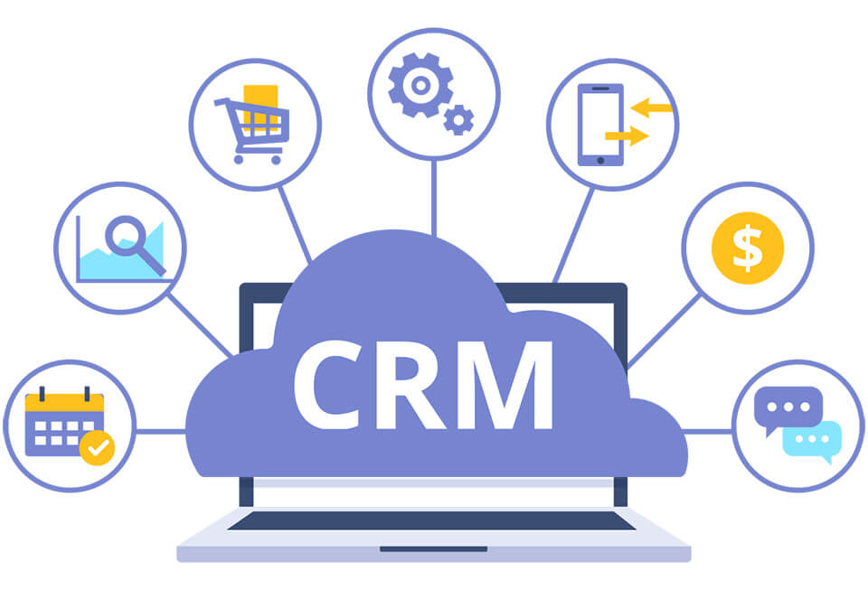

* 1. Details like items serial number, make model, warranty , department of control all these details will be mentioned in one place .
  2. Accessing & maintain the items details will easy.
  3. Identifying items for BR will become easy

1. To **streamline the complaint process**, allowing users to raise issues online and track their resolution.

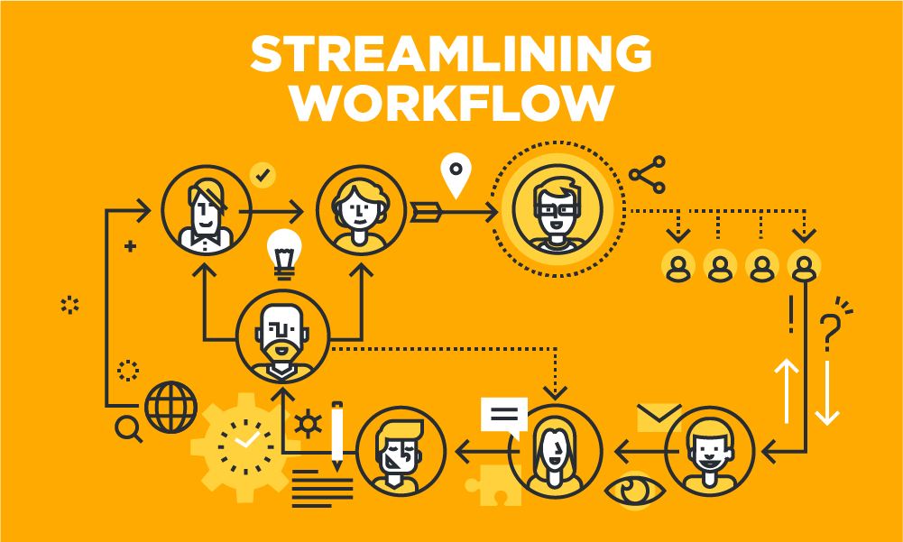

* 1. The users will be able to register complaints in the items through online.
  2. Can able to track the progress of the items
  3. Have accountability that what is the status of the item an

1. To **assign and monitor work** of AMC staff, ensuring accountability and transparency.



* 1. Amc staffs daily complaints attending will be registered
  2. Their progress for a complaint will be tracked
  3. Specific work can be assigned to a specific person

1. To maintain a **comprehensive database** of all network items for easy screening, auditing, and lifecycle tracking.



* 1. Thought digital database screening & managing items will become streamlined
  2. Auditing processes for the PC will become more efficient.

1. To act as a **knowledge-sharing platform**, providing IT manuals, guidelines, and updates to both users and AMC staff.



1. To host a **repository of drivers and software** related to AMC operations for quick and reliable access.

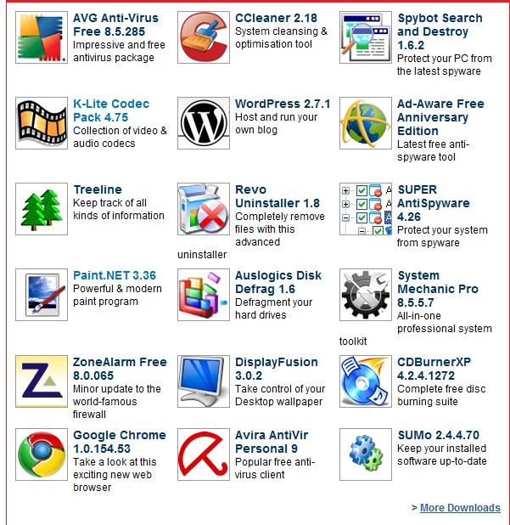

1. To enable **real-time updates and notifications** about network status, AMC activities, and technical updates.

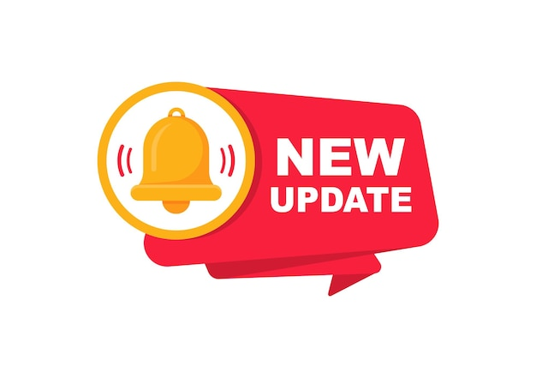

1. To provide **reports and progress tracking** for managers, users, and administrators to ensure SLA compliance and performance monitoring. To improve **accountability and efficiency** by capturing daily activities, asset usage, and AMC staff performance.

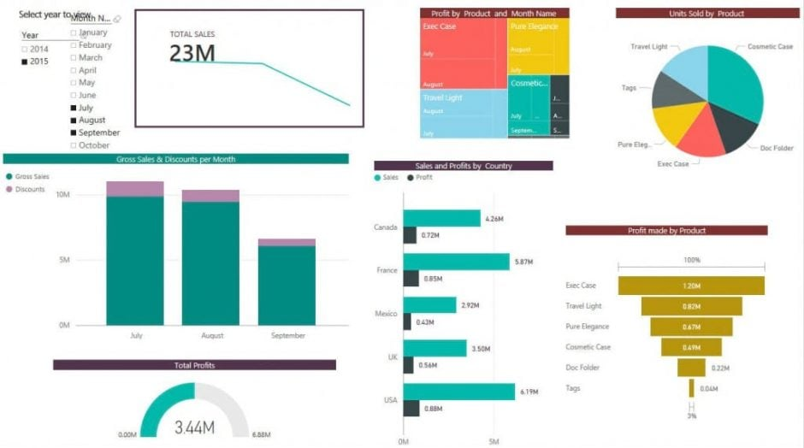

1. Advanced - optional feature To **monitor and track network devices** (like switches) for uptime and connectivity, reducing downtime and enabling proactive maintenance.

